WHAT WE WILL LEARN TODAY:
1. Briefly on exponents
2. A few laws of exponents
3. Expansions of various properties
EXPANSIONS

What are exponents?
Exponents are any number that can be written in a^{m}.
Let, a be any real number and m be the power. 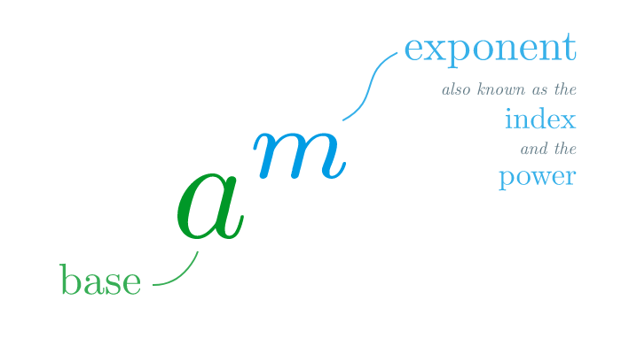
In exponents we multiply the base to the power times.
For example- 2³ =2×2×2=8

In the above example 2 is the base and 3 is the power or exponent. Whenever we get such exponents, we misread 2³as 2×3 but the actual or correct reading is 2×2×2.
3² = 2⁵ ⁼

Real numbers are any numbers like whole, natural, integers, fractions, rational and irrational numbers.
Laws of Exponents:
Let, a and b be any real number base, m and n be any real number exponent.
For example: we consider
a=3, b=5 and m=2,
First law- a^{m}×a^{n}= a^{m+n}
Important point: to apply this law both the bases have to be same. Powers may or may not be same.
So, 3²×3¹= 3²⁺¹
3³=3×3×3= 27

Second law- a^{m}÷a^{n}= a^{m-n}
So, 3²÷3¹= 3²⁻¹
3¹=3
Third laws- a^{m}×b^{m}= (ab)^{m}
So, 3²×5²= (3×5)²
Important point- to apply this law bases are different but power has to be the same.
15²= 15×15= 225

Question time:
i)4²×4¹= ii)2³×1³=
Use third law
Use first law

expansions:
let, a be 3 and be 5.
1.(a+b)²= a²+b²+2ab
(3+5)²= 3²+5²+2×3×5 = 9+25+30 =64
2. (a-b)²= a²+b²-2ab
(3-5)² ⁼3²+5²-2×3×5= 9+25-30=4
3. (a+b) (a-b) = a²-b²
(3+5) (3-5) = 3²-5² = 9-25= -6
Question time:
- 98²=
- (100+2) (100-2)=

